DESCRIPTIVE ANSWER OF DBMS

Q1 . Consider a dependency diagram of relation R and normalize it up to the third normal form.

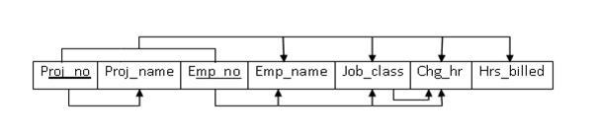

ANS .

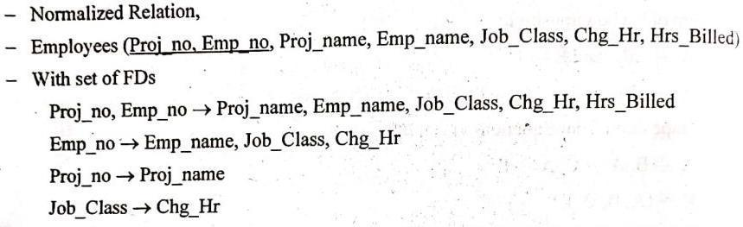

Q2. Explain conflict and view serializability with suitable examples .

ANS .

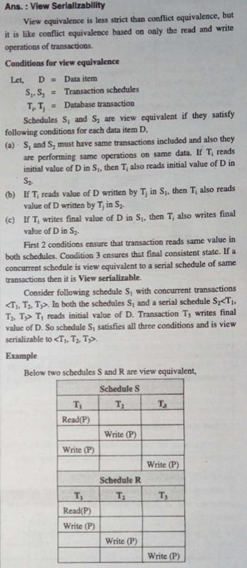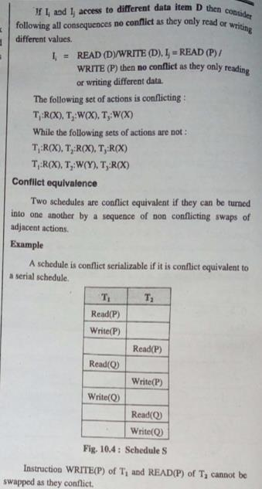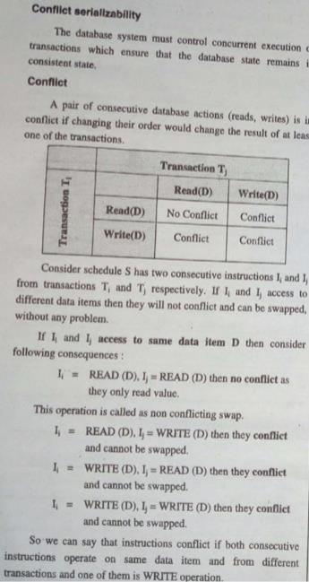

Q3. Explain deadlock handling in DBMS with suitable ex

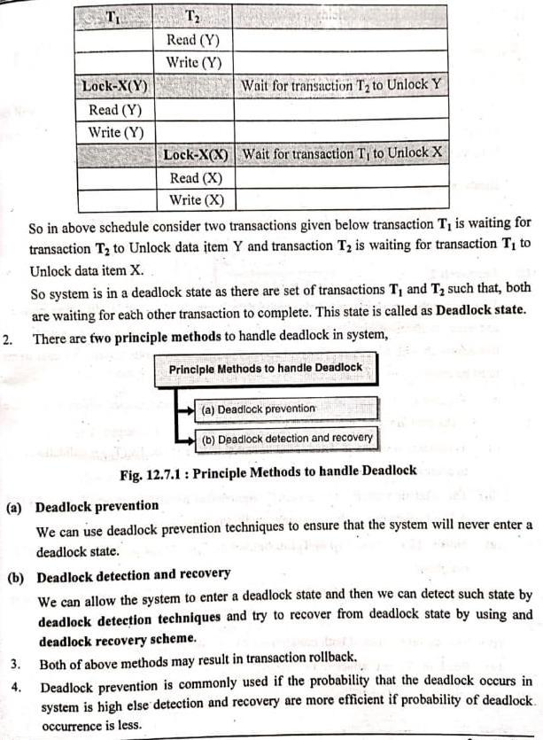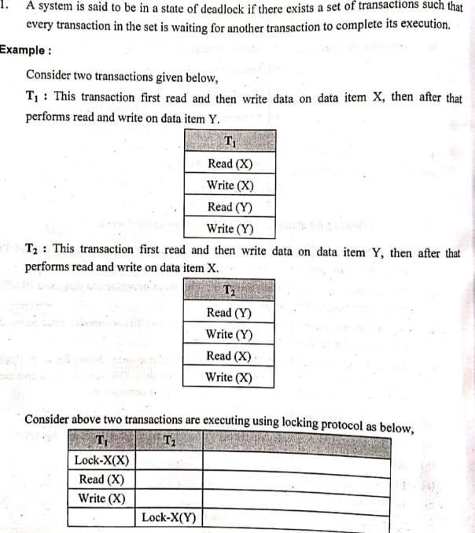

Q4. What are different database users? Give responsibilities of DBA

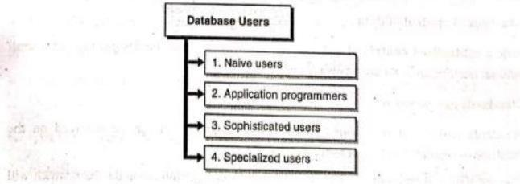

ANS .

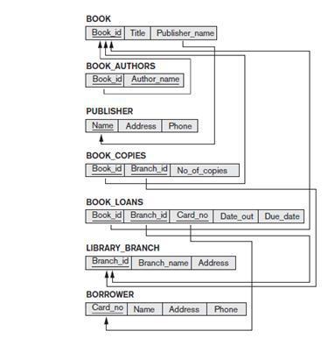

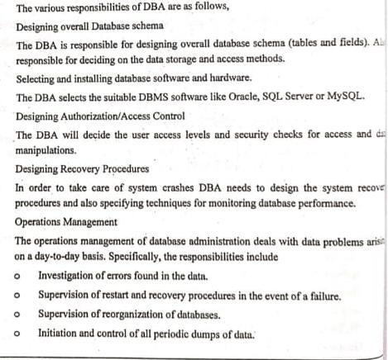Q5. Produce ER Diagram from the following relational database Schema.

ANS .

Q6. Book( book_id, title,author, cost)

Store(store_no, city, state, inventory_val)

Stock(store_no, book_id,quantity)

Consider above relational schema and formulate SQL queries for the following:

(i)Modify the cost of DBMS books by 10%

(ii)Find the author of the books which are available in Mumbai store (iii)Find the title of the most expensive book (iv)Find the total quantity of books in each store

1. Add a new record in Book(Assume values as per requirement)

ANS.

Q7. Explain the transaction processing with the help of a state diagram?

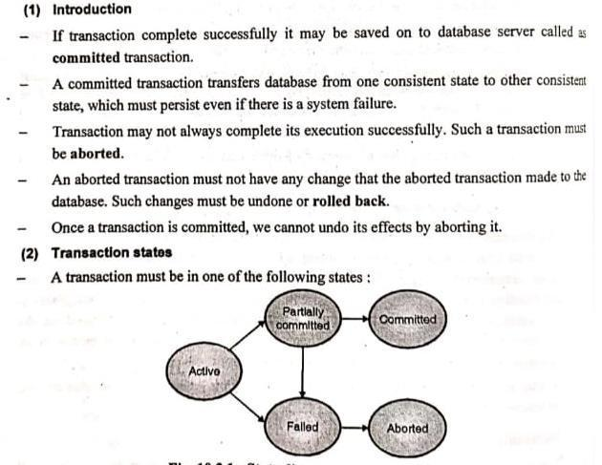

ANS.

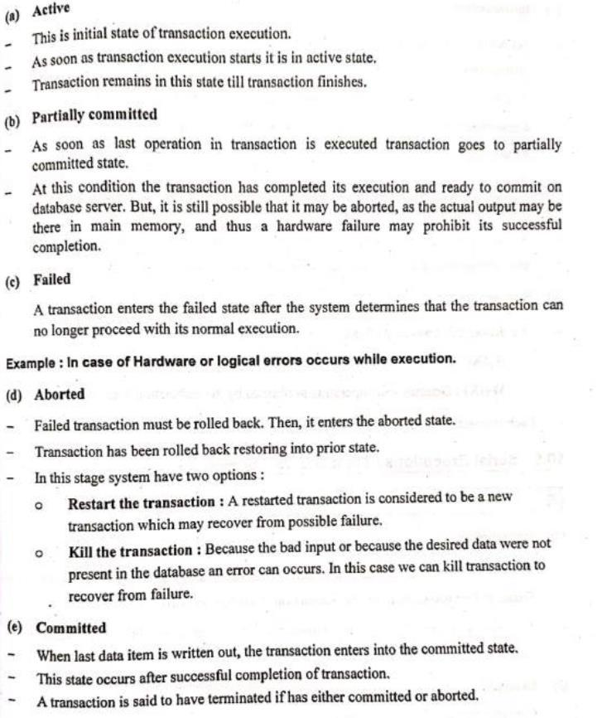

Q8. Consider the schema R={A,B,C,D,E,F,G,H,I,J} and set of functional dependencies

F= {{A,B}→{C}, {A}→{D,E}, {B}→ {F}, {F}→{G,H},{D}→{I,J}}.

What is the key of R?

Decompose R into 2NF and 3NF relations.

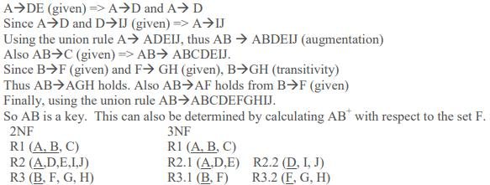

ANS.

09. Explain log based recovery techniques with examples?

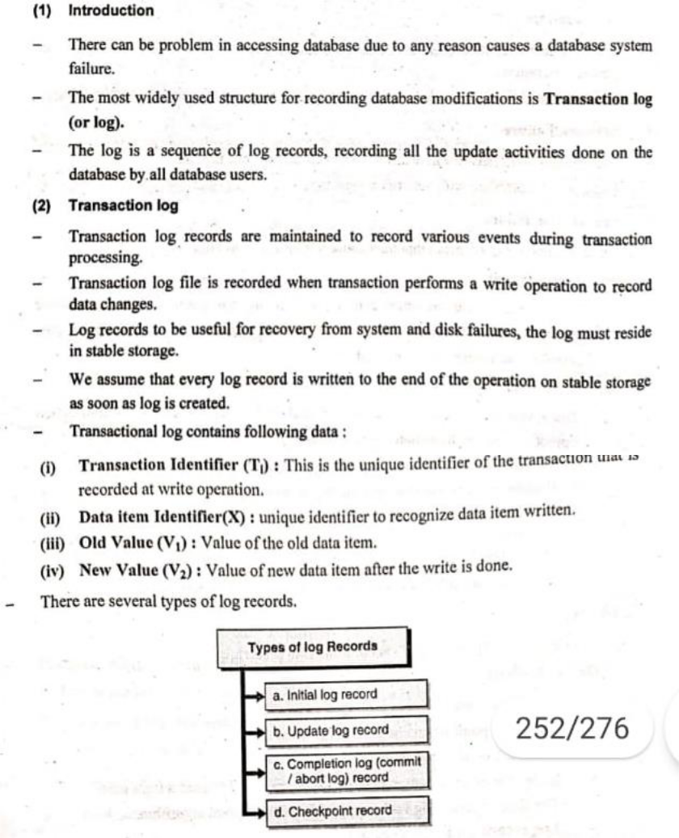

ANS .

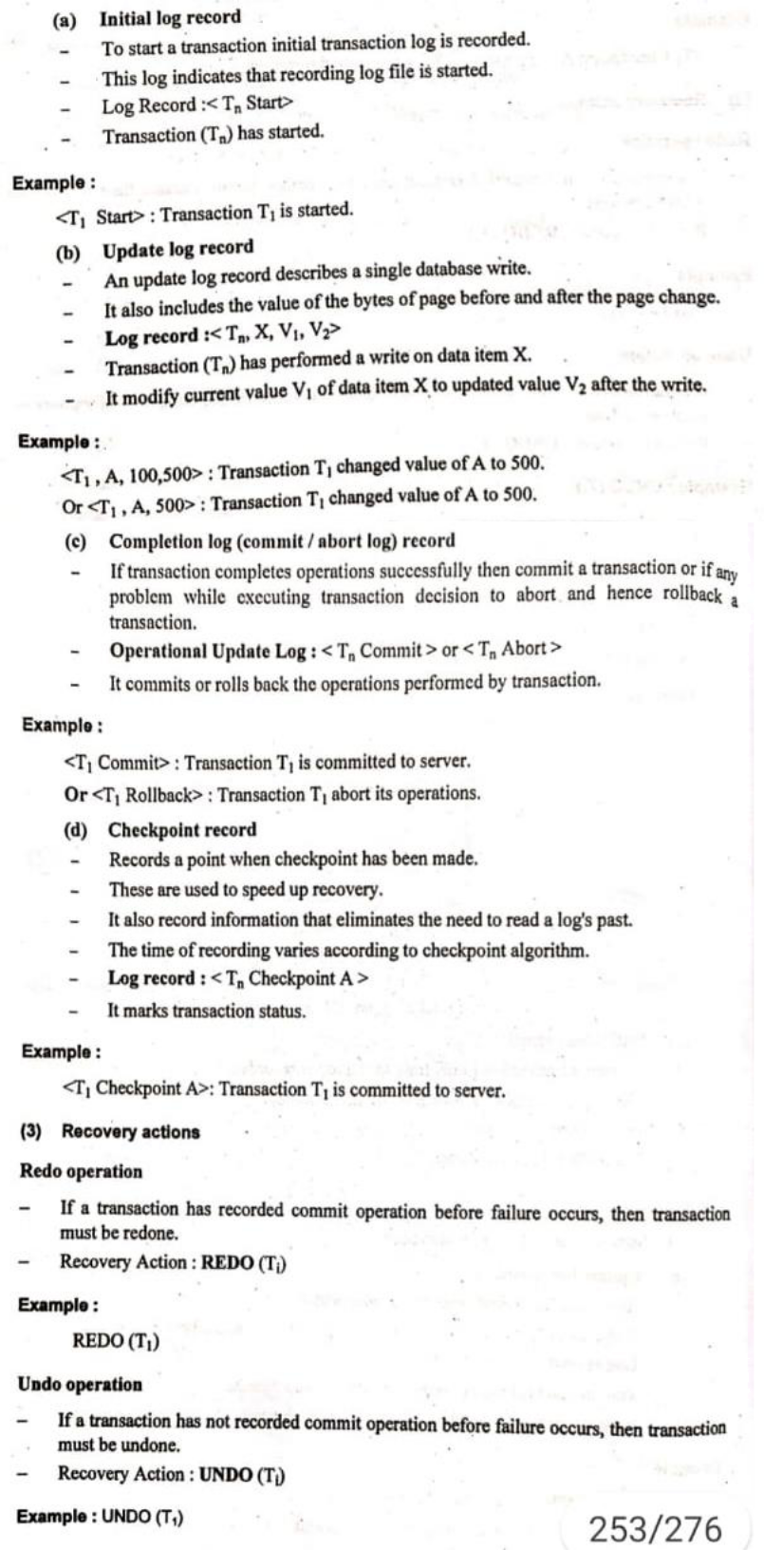

Q10. Explain different types of Database users and the responsibilities of the DBA?

ANS . SAME ANSWER OF Q4

Q11. Design an EER schema for a **BANK** database.

Each bank can have multiple branches, and each branch can have multiple accounts and loans. Bank keeps the track of different types of Accounts (Saving_aacount, Checking_account) , Loans(Car_loans,Home_loans,…) , each account’s Transaction (deposit, withdrawal,check,..) and each loan’s Payments; both of these include the amount, date and time.

State any assumptions you make about the additional requirement clearly.

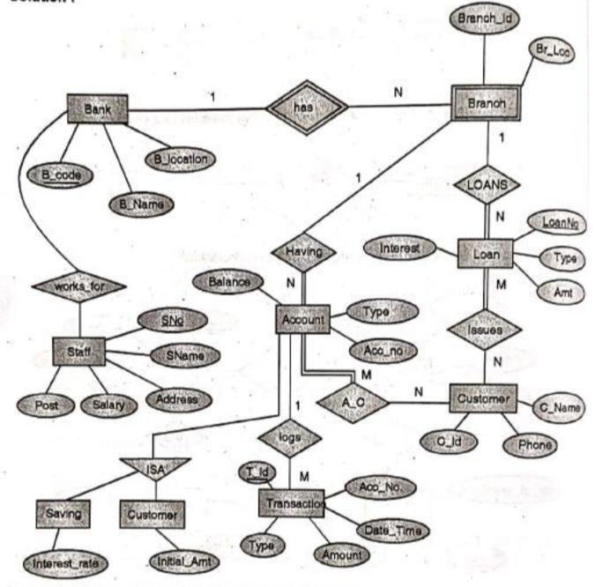

ANS .

Q12. Write SQL queries for the given database :

Emp(Eid, Ename, Sal, City)

Works(Eid, Cid)

Company(Cid, Cname, City)

1. Find the lowest paid employee.
2. Find how many employees are working for the company ‘ANZ Cooperation”.
3. Modify the database so that Joe now lives in “New York”.
4. Find the total number of employees of each company.
5. Give all employees of ‘XYZ ‘company a 10% raise in salary.

ANS.

Q13. Explain the three levels of abstraction in DBMS including physical and logical data independence.

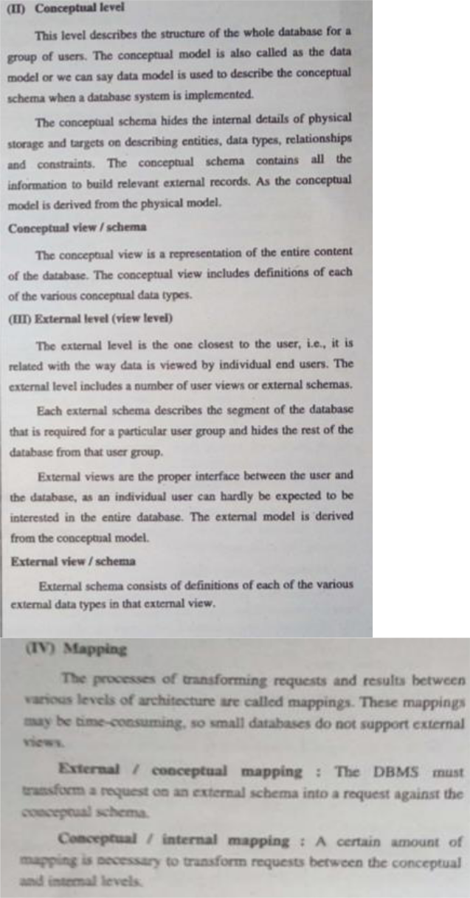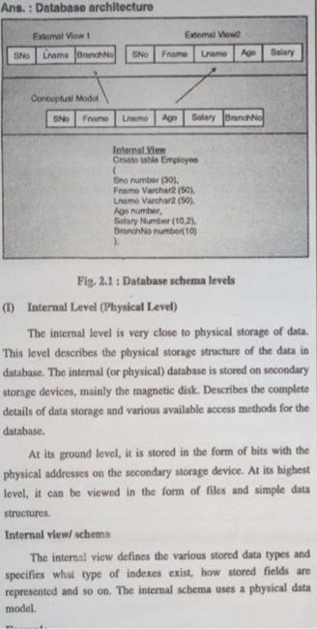

ANS .

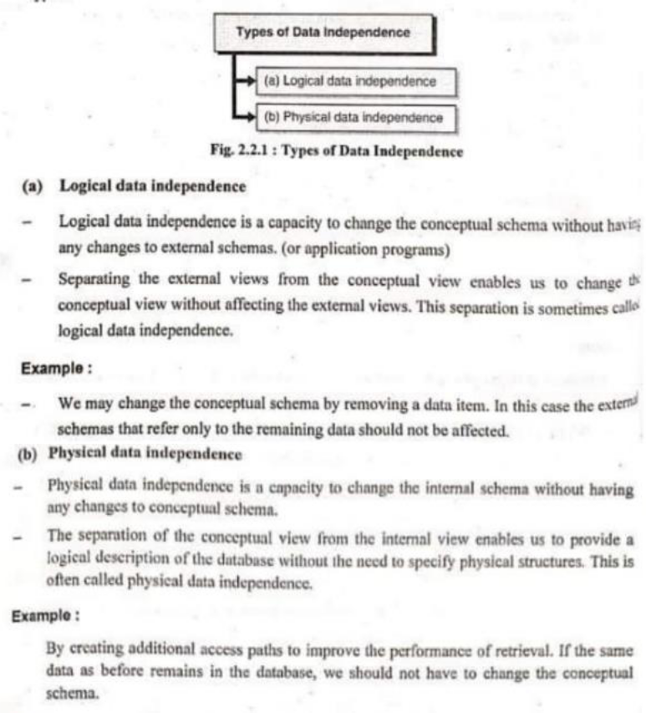

Q14. Consider the given schema:

* **Employees (**Empid, Fname, Lname, Email, Phoneno, Hiredate, Jobid, Salary, Mid, Did**)**
* **Departments** (Did, Dname,Managerid)
* **Locations** (Did, City,State)

1. List the employees who have a manager who works for a department based in Mumbai.
2. Give a 10% hike to all the Employees working in ‘**D01’** department.
3. Display the information of the employees whose first name starts with ‘R’ in descending order of their salary.
4. Find name of the department which are having more than 20 employees
5. Add a new record in departments(Assume values as per requirement)

ANS .

Q16. Explain 3NF .Consider relation r1 with the functional dependencies that hold on it.

r1(p, q, r, s, t)

p → q,r,s,t

s → t

check whether r1 is in 3NF or not .If it is not in 3NF decompose into 3NF.

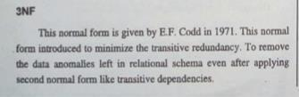

ANS .

DEFINITION: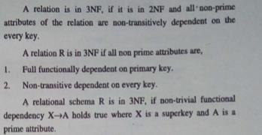

CHECK WHETHER IT IS IN 3NF OR NOT

Q17. Explain transaction ,properties and states with suitable example

ANS.

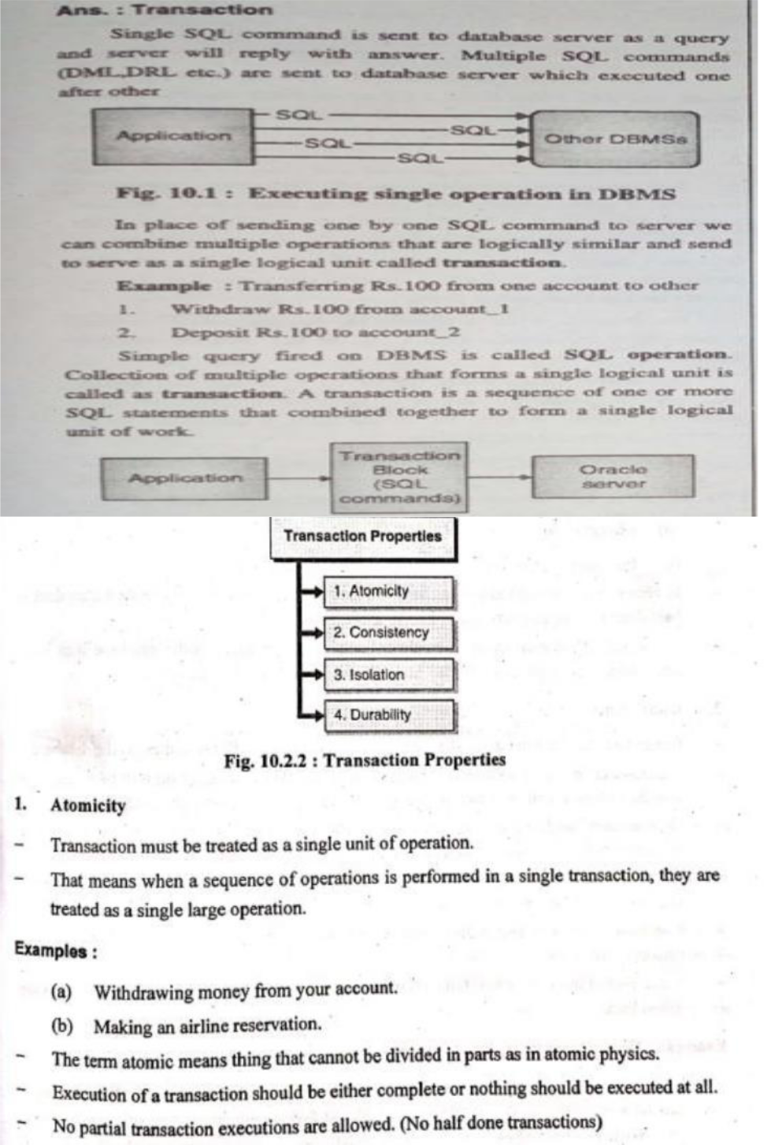

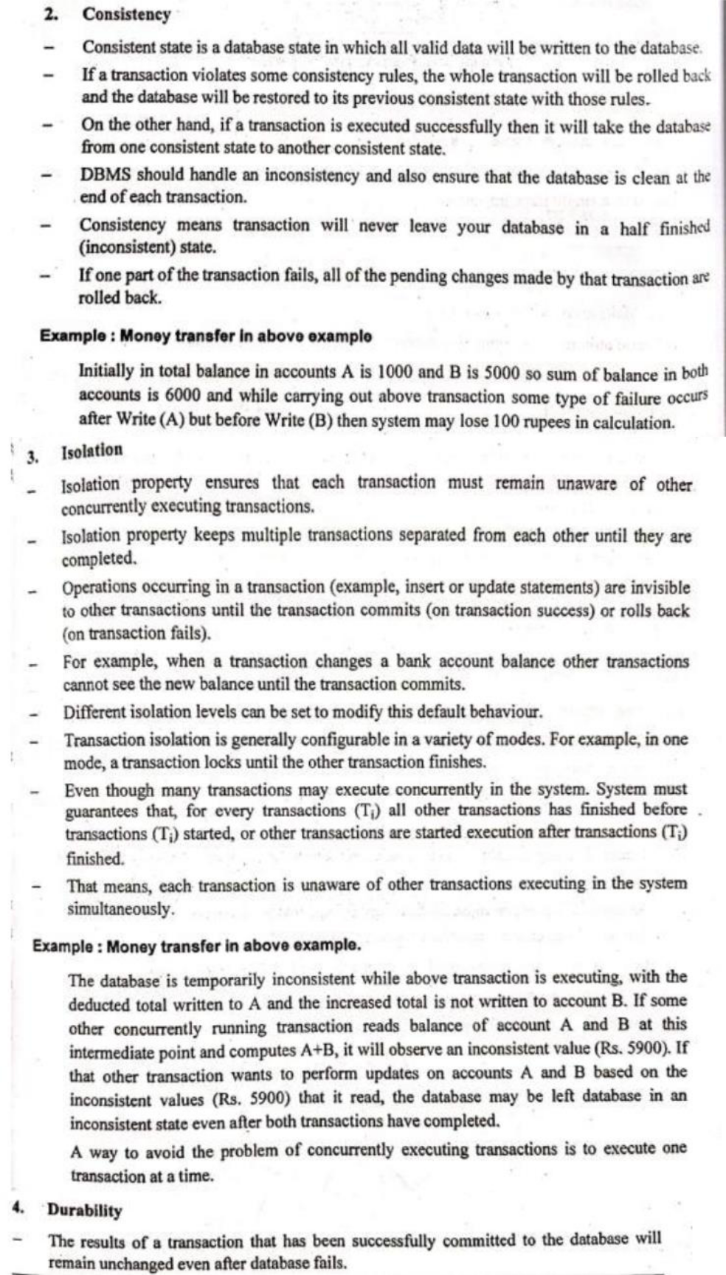

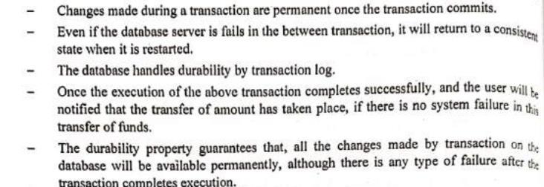

Q18. Explain timestamp based protocol and how timestamp-ordering protocol guarantees serializability

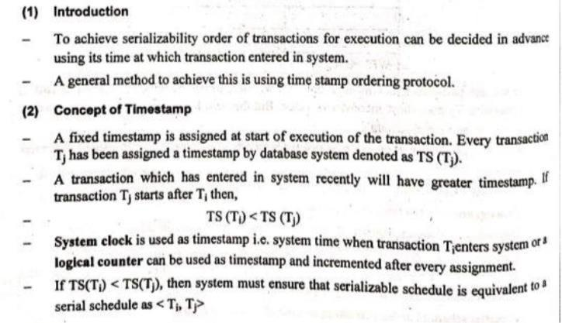

ANS.

